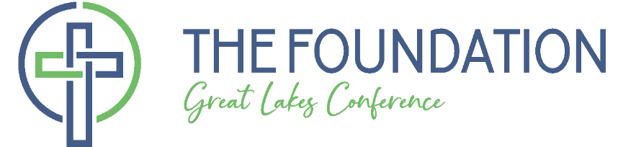
Year 2023
Grant Application – Micro Grants for Kingdom Reach

Instructions:
- This short form is intended for GLC congregations/agencies to seek funds not to exceed $5,000 specifically for missional outreach and/or reproducing disciple making ministries that satisfy The Foundation’s 501c3 status.
- Answer each of the following questions by filling in the gray box.
- Two signatures are required at the conclusion of the request.
- Application deadline – December 10, 2023
- Scan and email this completed and signed request to: foundationdirector@cggc.org
or mail to: The Foundation of the GLC, 700 East Melrose Avenue, Findlay, OH 45840

Questions:
- What is the official name, address and phone number of the Grant Seeker?

- Who is the primary contact person for the Grant Seeker, including address, phone, and email?

- Describe the proposed Project/Ministry and ways this will reach the community with the Gospel and/or stimulate reproducing disciple making.

- How will this Project/Ministry be funded? (Preferential consideration is given to matched funding.)
Total Cost of the Ministry/Project $
Amount self-funded by cash or contributions $
Amount requested from The Foundation $

- What additional operational expense or continuing financial support is projected and how will it be met?

- What are the measures of success and who will evaluate this project for effectiveness?

- Describe the timeline projected for this Project/Ministry including the date of formal support by the governing body of the congregation/agency. Formal support may be made by electronic vote.

Authorized Signatures:
We submit this Application as Authorized Signatories of and with formal support of the Applicant Organization and affirm the accuracy of this application.

________________________________ _________________ _____________
Signature Title Date

________________________________ Pastor _____________
Signature Title Date

